Contents

**📑 Data Analysis Methodology** 2

**1. Data Source** 2

**2. Data Preparation** 2

**3. Normality Testing** 2

**4. Correlation Analysis** 2

**5. Trend Analysis** 2

Table 1. Descriptive Statistics 4

Table 2.Tests of Normality 5

Table 3.Spearman’s Rank Correlation Between Dates and Total Reads 8

Figure 1.Histogram of Total Reads per Day 6

Figure 2.Histogram of Highest Reads per Day 6

Figure 3. Histogram of Lowest Reads per Day 7

Figure 4.Histogram of Reads' average per Day 7

Figure 5.Line Graph of Total Reads Across 31 Days 8

**📑 Data Analysis Methodology**

**1. Data Source**

* Radiation readings were obtained from Open data website. It contained daily read during August 2024 over a period of **31 consecutive days**.

**2. Data Preparation**

* The dataset was checked for **missing values** (none was found).
* For each day, the following measures were calculated:
  + **Total reads per day**
  + **Highest read per day**
  + **Lowest read per day**
  + **Average of reads per day**
* **Descriptive statistics** (mean, median, standard deviation, range, minimum, maximum) were computed to summarize the distribution of each variable. Table 1.

**3. Normality Testing**

* To assess whether the data followed a normal distribution, both the **Kolmogorov–Smirnov test** and the **Shapiro–Wilk test** were applied. Table 2.
* Results indicated that:
  + *Total reads* and *Lowest reads* significantly deviated from normality (p < .001).
  + *Highest reads* did not significantly deviate from normality (p > .05).
  + *Average reads* also deviate from normality (p < .001).
* Based on these results, **non-parametric methods** were chosen for correlation analysis.

**4. Correlation Analysis**

1. The relationship between **Dates (time progression)** and **Total reads** was examined using **Spearman’s rank-order correlation (ρ)**, which does not assume normality. Table 3
2. Results:
   * Spearman’s rho = **.310**
   * p = **.089** (not statistically significant at α = .05)
   * 95% CI = **[–.082, .669]**
3. Interpretation: A weak positive monotonic trend was observed, but the evidence was insufficient to conclude a reliable increase in radiation readings over time.

**5. Trend Analysis**

* Visual inspection of the time series revealed:
  1. An **early dip** (Days 0–2).
  2. A **steady rise** (Days 2–7).
  3. A **plateau** (Days 7–12).
  4. A **gradual decline** (Days 12–16).
* While fluctuations were evident, the overall pattern remained within a relatively narrow range (14,900–16,150).

**Descriptive statistics:**

Table 1. Descriptive Statistics

|  |  |  |
| --- | --- | --- |
| **Statistics** | | |
| Total reads per day | | |
| N | Valid | 31 |
| Missing | 0 |
| Mean | | 15843.07 |
| Median | | 15900.08 |
| Std. Deviation | | 247.76 |
| Range | | 1230.62 |
| Minimum | | 14910.70 |
| Maximum | | 16141.33 |
| Highest read per day | | |
| N | Valid | 31 |
| Missing | 0 |
| Mean | | 121.25 |
| Median | | 121.50 |
| Std. Deviation | | 1.91 |
| Range | | 7.16 |
| Minimum | | 117.14 |
| Maximum | | 124.30 |
| Lowest read per day | | |
| N | Valid | 31 |
| Missing | 0 |
| Mean | | 99.42 |
| Median | | 100.0 |
| Std. Deviation | | 2.84 |
| Range | | 11.30 |
| Minimum | | 91.50 |
| Maximum | | 102.80 |
| Average of reads per day | | |
| N | Valid | 31 |
| Missing | 0 |
| Mean | | 110.02 |
| Median | | 110.42 |
| Std. Deviation | | 1.72 |
| Range | | 8.55 |
| Minimum | | 103.55 |
| Maximum | | 112.09 |

**Normality testing:**

Table 2.Tests of Normality

|  |  |  |  |  |  |  |  |  |  |  |  |  |  |  |  |  |  |  |  |  |  |  |  |  |
| --- | --- | --- | --- | --- | --- | --- | --- | --- | --- | --- | --- | --- | --- | --- | --- | --- | --- | --- | --- | --- | --- | --- | --- | --- |
| **Tests of Normality** | | | | | | | | | | | | | | | | | | | | | | | | |
|  | | | | Kolmogorov-Smirnova | | | | | | | | | | | | Shapiro-Wilk | | | | | | | | |
| Statistic | | | | df | | | | Sig. | | | | Statistic | | | | df | | | | Sig. |
| Total reads per day | | | | .231 | | | | 31 | | | | <.001 | | | | .754 | | | | 31 | | | | <.001 |
| a. Lilliefors Significance Correction | | | | | | | | | | | | | | | | | | | | | | | | |
|  | | | Kolmogorov-Smirnova | | | | | | | | | | | Shapiro-Wilk | | | | | | | | | | | |
| Statistic | | | df | | | | Sig. | | | | Statistic | | | | df | | | | Sig. | | | |
| Highest read per day | | | .097 | | | 31 | | | | .200* | | | | .950 | | | | 31 | | | | .157 | | | |
| *. This is a lower bound of the true significance. | | | | | | | | | | | | | | | | | | | | | | | | | |
| a. Lilliefors Significance Correction | | | | | | | | | | | | | | | | | | | | | | | | | |
|  | Kolmogorov-Smirnova | | | | | | | | | | | | Shapiro-Wilk | | | | | | | | | | | | |
| Statistic | | | | df | | | | Sig. | | | | Statistic | | | | df | | | | Sig. | | | | |
| Lowest read per day | .221 | | | | 31 | | | | <.001 | | | | .810 | | | | 31 | | | | <.001 | | | | |
| a. Lilliefors Significance Correction | | | | | | | | | | | | | | | | | | | | | | | | | |
|  | | Kolmogorov-Smirnova | | | | | | | | | | | | | Shapiro-Wilk | | | | | | | | | | |
| Statistic | | | | | df | | | | Sig. | | | | Statistic | | | | df | | | | Sig. | | |
| Average of reads per day | | .231 | | | | | 31 | | | | <.001 | | | | .754 | | | | 31 | | | | <.001 | | |
| a. Lilliefors Significance Correction | | | | | | | | | | | | | | | | | | | | | | | | | |

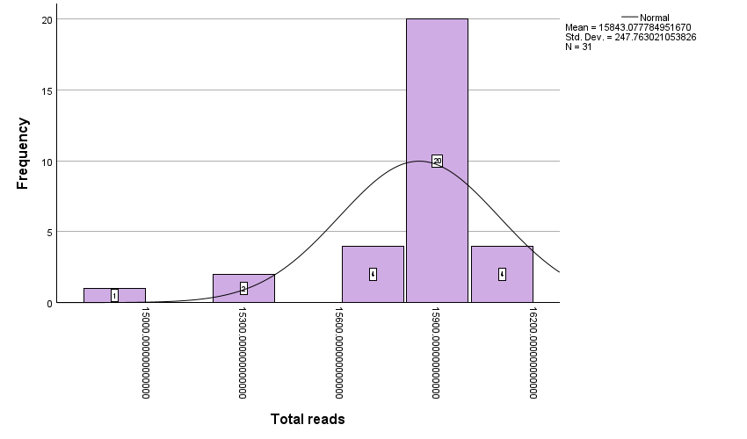

Figure 1.Histogram of Total Reads per Day

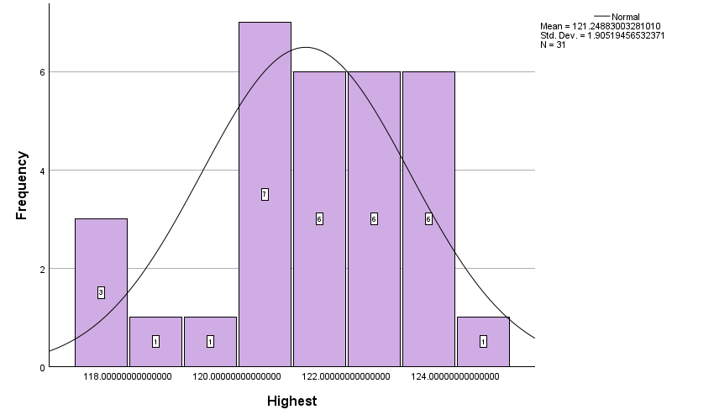

Figure 2.Histogram of Highest Reads per Day

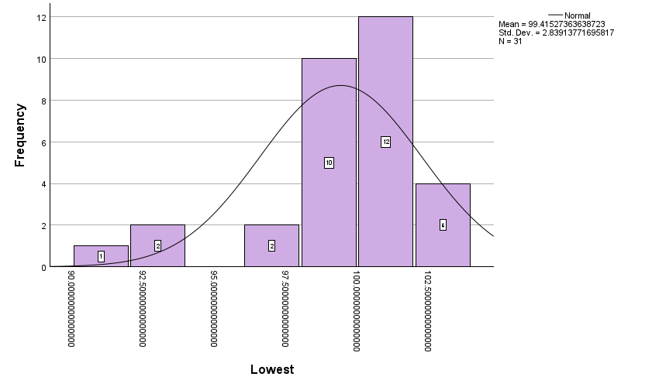

Figure 3. Histogram of Lowest Reads per Day

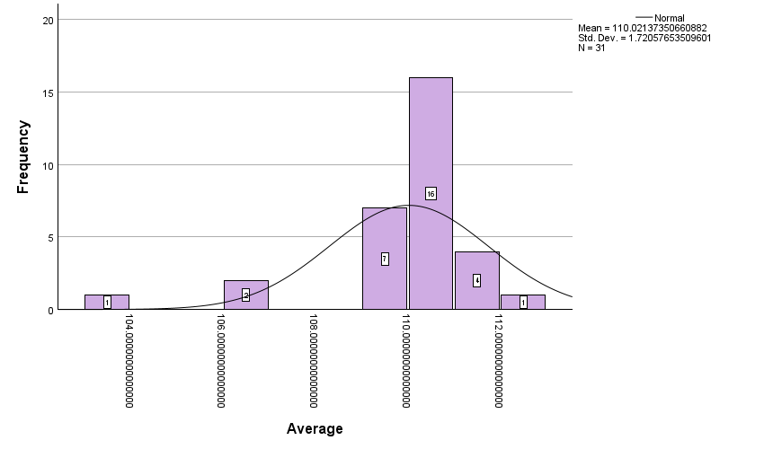

Figure 4.Histogram of Reads' average per Day

**Correlation:**

Table 3.Spearman’s Rank Correlation Between Dates and Total Reads

|  |  |  |  |  |
| --- | --- | --- | --- | --- |
| **Confidence Intervals of Spearman's rho** | | | | |
|  | Spearman's rho | Significance(2-tailed) | 95% Confidence Intervals (2-tailed)a,b | |
| Lower | Upper |
| Dates - Total reads | .310 | .089 | -.060 | .606 |
| a. Estimation is based on Fisher's r-to-z transformation. | | | | |
| b. Estimation of standard error is based on the formula proposed by Fieller, Hartley, and Pearson. | | | | |

• There is a **possible weak upward trend** in radiation readings across the 31 days. However, the evidence is **not strong enough** to conclude a reliable monotonic increase. The wide confidence interval shows that with more data, the correlation could shift in either direction.

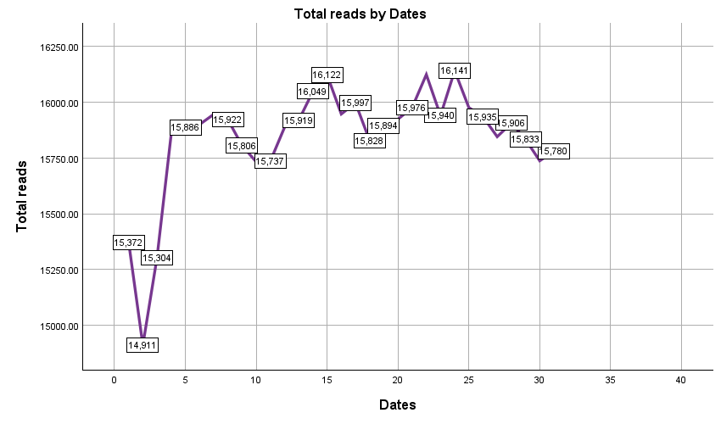

Figure 5.Line Graph of Total Reads Across 31 Days

**Trend Overview:**

* **Range**: Radiation counts fluctuate between **14,900 and 16,150**.
* **Pattern**:
  1. **Early dip** (Day 0–2): A drop from 15,372 → 14,911.
  2. **Steady rise** (Day 2–7): Sharp recovery, peaking at 16,122.
  3. **Plateau** (Day 7–12): Stable high readings around 16,100–16,145.
  4. **Gradual decline** (Day 12–16): Down to 15,780, still above the initial low.